Curriculum: Science

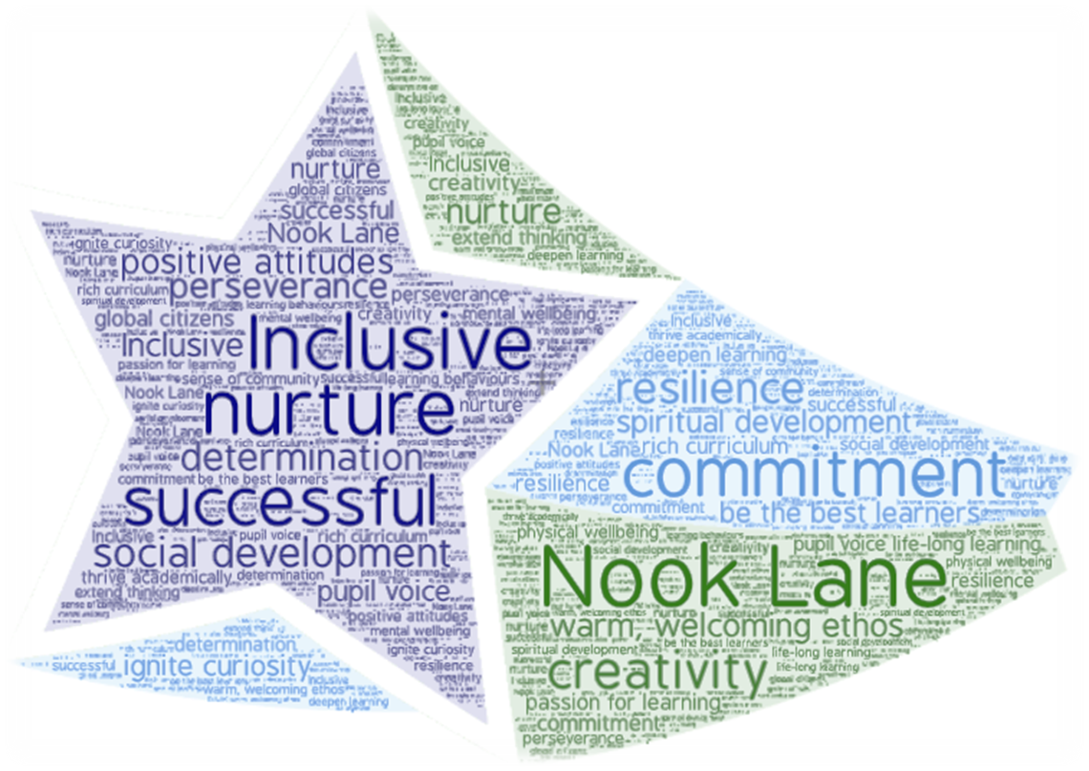

- Vision
- Intent, Implementation & Impact
- National Curriculum
- Overview of learning
- Progression

Vision

At Nook Lane Junior School, children receive high-quality Science lessons that enable them to develop a strong understanding of the world around them whilst acquiring specific skills and knowledge to help them think scientifically, gain an understanding of scientific processes and also understand the uses and implications of Science, today and for the future. Teaching ensures that children will acquire the knowledge and understanding above through engaging and purposeful scientific enquiry, enabling them to answer scientific questions.
We aim to stimulate and ignite children’s curiosity through finding out why things happen in the way they do and it is our vision to instil a lifelong love of science within our pupils through engagement and inspiration. Scientific enquiry skills are embedded in each topic that the children study and these topics are revisited and developed throughout their time at school enabling enduring connections and fostering deeper understanding. All children are encouraged to question the world around them and become independent learners in exploring possible answers for their scientific-based questions in order to appreciate the way Science will affect their future on a personal, national, and global level, enabling children to become responsible global citizens. We want pupils to think critically and communicate their ideas in a variety of different ways using a well-developed scientific vocabulary.
Intent
At Nook Lane Junior School, we aspire to help children develop as designers, building progressively each year on the following Science key intentions:
SC1 |  | Children will develop scientific knowledge and conceptual understanding through the specific disciplines of biology, chemistry and physics.
SC2 |  | Children acquire the necessary skills to and ask questions, some of which children devise themselves, about change, cause, similarity, difference and significance and investigate by carrying out fair and comparative tests.
SC3 |  | Children can observe and measure changes and reflect upon these.
SC4 |  | Children can identify, classify, record and present data and results of increasing complexity.
SC5 |  | Children acquire the skills to use knowledge and scientific evidence to draw conclusions, notice patterns and present findings.
SC6 |  | Children develop the necessary skills to use scientific evidence and secondary sources of information to support and refute scientific ideas.
Key Concepts |  | Thoughout their learning, children will develop an in-depth understanding of the following concepts that are continually returned to and discussed within each unit of learning so they can answer the ‘bigger questions’ listed below:  1. Working Scientifically – How does asking questions, designing enquiries, reasoning and arguing with Scientific evidence and analysing and interpreting data help us to improve as scientists and learn more about the world around us?  2. Adaptation – What processes have taken place to allow animals, plants and other living things to thrive and reproduce?  3. Changes – How do things change over time and why do these changes occur?  4. Forces and energy – What do you understand about forces and energy? How do we use these to achieve a specific outcome?  5. Properties - What properties of materials allow them to be used for different purposes?
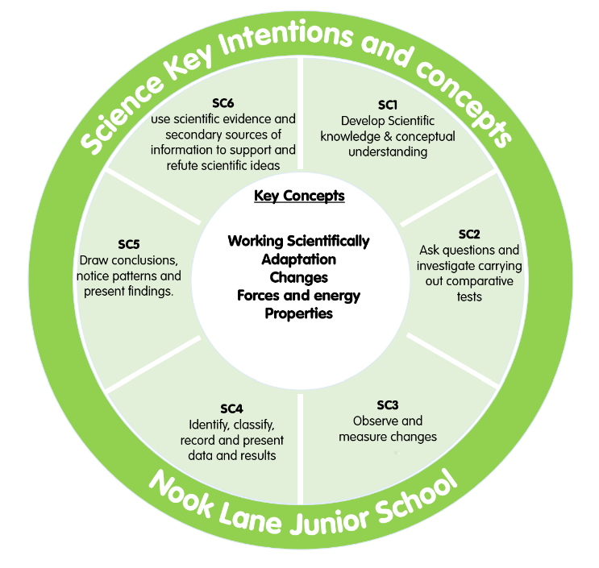
Our Science key intentions and concepts are captured within our Science Logo.

Implementation
- Units of study that are a requirement of the national curriculum have been mapped-out for each year group (see Science overview of learning)
- Key knowledge, skills and understanding are identified at the start of each Science unit of work that link back to our key intentions, ensuring that all they key intentions are covered at least once within each history unit of work.
- All Science lessons are designed to link to at least one of our Science key intentions and our curriculum intentions.
- Children are given the opportunity to complete memory mats each lesson helping children to revise key learning each week to help children commit learning to their long-term memory.
- Scientific skills are mapped-out progressively within each year group ensuring that children make progress in their skillset year-on-year.
Impact
- Children will develop a love for Science and enquiring minds that seek to ask and Scientific.answer questions.
- Age related outcomes in Science will be above the national average in Science.
- Children will retain knowledge that is pertinent to Science with a real life context.
- Children will be able to question ideas and reflect on knowledge.
- Children will work collaboratively and practically to investigate and experiment.
- Children will be able to explain the process they have taken and be able to reason scientifically.

National Curriculum
A high-quality science education provides the foundations for understanding the world through the specific disciplines of biology, chemistry and physics. Science has changed our lives and is vital to the world’s future prosperity, and all pupils should be taught essential aspects of the knowledge, methods, processes and uses of science. Through building up a body of key foundational knowledge and concepts, pupils should be encouraged to recognise the power of rational explanation and develop a sense of excitement and curiosity about natural phenomena. They should be encouraged to understand how science can be used to explain what is occurring, predict how things will behave, and analyse causes.

Aims
The national curriculum for science aims to ensure that all pupils:
- develop scientific knowledge and conceptual understanding through the specific disciplines of biology, chemistry and physics
- develop understanding of the nature, processes and methods of science through different types of science enquiries that help them to answer scientific questions about the world around them
- are equipped with the scientific knowledge required to understand the uses and implications of science, today and for the future
- Scientific knowledge and conceptual understanding
- The programmes of study describe a sequence of knowledge and concepts. While it is important that pupils make progress, it is also vitally important that they develop secure understanding of each key block of knowledge and concepts in order to progress to the next stage. Insecure, superficial understanding will not allow genuine progression: pupils may struggle at key points of transition (such as between primary and secondary school), build up serious misconceptions, and/or have significant difficulties in understanding higher-order content.
- Pupils should be able to describe associated processes and key characteristics in common language, but they should also be familiar with, and use, technical terminology accurately and precisely. They should build up an extended specialist vocabulary. They should also apply their mathematical knowledge to their understanding of science, including collecting, presenting and analysing data. The social and economic implications of science are important but, generally, they are taught most appropriately within the wider school curriculum: teachers will wish to use different contexts to maximise their pupils’ engagement with and motivation to study science.
- The nature, processes and methods of science
- ‘Working scientifically’ specifies the understanding of the nature, processes and methods of science for each year group. It should not be taught as a separate strand. The notes and guidance give examples of how ‘working scientifically’ might be embedded within the content of biology, chemistry and physics, focusing on the key features of scientific enquiry, so that pupils learn to use a variety of approaches to answer relevant scientific questions. These types of scientific enquiry should include: observing over time; pattern seeking; identifying, classifying and grouping; comparative and fair testing (controlled investigations); and researching using secondary sources. Pupils should seek answers to questions through collecting, analysing and presenting data. ‘Working scientifically’ will be developed further at key stages 3 and 4, once pupils have built up sufficient understanding of science to engage meaningfully in more sophisticated discussion of experimental design and control.

Spoken language
- The national curriculum for science reflects the importance of spoken language in pupils’ development across the whole curriculum – cognitively, socially and linguistically. The quality and variety of language that pupils hear and speak are key factors in developing their scientific vocabulary and articulating scientific concepts clearly and precisely. They must be assisted in making their thinking clear, both to themselves and others, and teachers should ensure that pupils build secure foundations by using discussion to probe and remedy their misconceptions.

School curriculum
- The programmes of study for science are set out year-by-year for key stages 1 and 2. Schools are, however, only required to teach the relevant programme of study by the end of the key stage. Within each key stage, schools therefore have the flexibility to introduce content earlier or later than set out in the programme of study. In addition, schools can introduce key stage content during an earlier key stage if appropriate. All schools are also required to set out their school curriculum for science on a year-by-year basis and make this information available online.

Attainment targets
- By the end of each key stage, pupils are expected to know, apply and understand the matters, skills and processes specified in the relevant programme of study.

Overview of learning
 |  |  | Autumn 1 | Autumn 2 |  |  | Spring 1 |  |  |  | Spring 2 | Summer 1 |  |  | Summer 2
Year 3 |  |  | Light and how we see things |  |  |  | Rocks and soils |  |  |  | Forces and magnets | Plants and how they live and reproduce |  |  | Understanding animals including humans
Year 4 |  |  | Animals including humans. | Sound and  pitch |  |  | Electrical  sources |  |  |  | States of  matter | Classifying living things
Year 5 |  |  | Properties of materials | Gravity and friction |  |  | Life Cycles |  |  |  |  | Earth & Space |  |  | Changes that happen to the human body  Reversible & Irreversible materials
Year 6 |  |  | Light linked to making trench periscopes | Animals including humans |  |  | Evolution and inheritance |  |  |  | Electricity and circuits | Living things and their habitats
Subject Progression
Develop scientific knowledge and conceptual understanding through the specific disciplines of biology, chemistry and physics
See Science Knowledge Coverage and Progression

NC: Develop scientific knowledge and conceptual understanding within the areas listed below:
Year 3 |  |  |  |  | Year 4 |  |  |  | Year 5 |  |  |  | Year 6
- How plants and how they live and reproduce  - Animals and how they move  - Light and shadows  - Magnets and forces  - Rocks |  |  |  |  | - Classify living things  - Digestion in humans  - Sound and pitch  - Electrical sources  - States of matter |  |  |  | - Life cycles and reproduction patterns of plants and animals  - Changes that happen to the human body  - Gravity and friction  - Reversible and irreversible changes  - Earth and space |  |  |  | - Classifying animals  - How the human body works and how to stay healthy  - How light behaves  - Electrical circuits  - Evolution and inheritance
Plants and how they live and reproduce |  |  |  |  | Classify living things using keys |  |  |  | Life cycles and reproduction patterns of plants and animals |  |  |  | Classifying animals
 | - Identify and describe functions of different parts of flowering plants: roots, stem/trunk, leaves, flowers  - Explore the requirements of plants for life and growth (air, light, water, nutrients from soil, and room to grow) and how they vary from plant to plant Investigate the way in which water is transported within plants  Living things and their habitats  - Explore the part that flowers play in the life cycle of flowering plants, including pollination, seed formation and seed dispersal. |  |  |  | - Recognise that living things can be grouped in a variety of ways  - Explore and use classification keys to help group, identify and name a variety of living things in their local and wider environment  - Recognise that environments can change and that this can sometimes pose dangers to living things. |  |  |  | - Describe the differences in the life cycles of a mammal, an amphibian, an insect and a bird  - Describe the life process of reproduction in some plants and animals. |  |  |  | - Describe how living things are classified into broad groups according to common observable characteristics and based on similarities and differences, including microorganisms, plants and animals  - Give reasons for classifying plants and animals based on specific characteristics.
Understanding animals |  |  |  |  | Digestion in humans |  |  |  | Changes that happen to the human body |  |  |  | Understanding how my body works and how to stay healthy.
 | - Identify that animals, including humans, need the right types and amount of nutrition, and that they cannot make their own food; they get nutrition from what they eat  Animals including humans  - Identify that humans and some other animals have skeletons and muscles for support, protection and movement. |  |  |  |  | - Describe the simple functions of the basic parts of the digestive system in humans  - Identify the different types of teeth in humans and their simple functions  - Construct and interpret a variety of food chains, identifying producers, predators and prey. |  |  |  | - Describe the changes as humans develop to old age. |  |  |  | - Identify and name the main parts of the human circulatory system, and describe the functions of the heart, blood vessels and blood  - Recognise the impact of diet, exercise, drugs and lifestyle on the way their bodies function  - Describe the ways in which nutrients and water are transported within animals, including humans.
Light and shadows |  |  |  |  |  | Sound and pitch |  |  |  |  |  |  |  | Understanding how light behaves
 | - Recognise we need light to see things and that dark is the absence of light  - Notice that light is reflected from surfaces  - Recognise that light from the sun can be dangerous and that there are ways to protect their eyes Recognise that shadows are formed when the light from a light source is blocked by an opaque object  Light and sound  - Find patterns in the way that the size of shadows change. |  |  |  |  | - Identify how sounds are made, associating some of them with something vibrating  - Recognise that vibrations from sounds travel through a medium to the ear  - Find patterns between the pitch of a sound and features of the object that produced it  - Find patterns between the volume of a sound and the strength of the vibrations that produced it  - Recognise sounds get fainter as distance from sound source increases. |  |  |  |  |  |  |  | - Recognise that light appears to travel in straight lines  - Use the idea that light travels in straight lines to explain that objects are seen because they give out or reflect light into the eye  - Explain that we see things because light travels from light sources to our eyes or from light sources to objects and then to our eyes  - Use the idea that light travels in straight lines to explain why shadows have the same shape as the objects that cast them.
Magnets and forces |  |  |  |  |  | Electrical sources |  |  |  | Gravity and friction |  |  |  | Electrical circuits
 | - Compare how things move on different surfaces  - Notice some forces need contact between two objects, but magnetic forces act at a distance  - Observe how magnets attract or repel each other and attract some materials and not others Compare and group together a variety of everyday materials on the basis of whether they are attracted to a magnet, and identify some magnetic materials  Forces and electricity  - Describe magnets as having two poles  - Predict whether two magnets will attract or repel each other. |  |  |  |  | - Identify common appliances that run on electricity  - Construct a simple series electrical circuit, identifying and naming its basic parts, including cells, wires, bulbs, switches and buzzers  - Identify whether or not a lamp will light in a simple series circuit, based on whether or not the lamp is part of a complete loop with a battery  - Recognise that a switch opens and closes a circuit and associate this with whether or not a lamp lights in a simple series circuit  - Recognise common conductors and insulators, and associate metals with being good conductors. |  |  |  | - Explain that unsupported objects fall towards the Earth because of the force of gravity acting between the Earth and the falling object  - Identify the effects of air resistance, water resistance and friction, that act between moving surfaces  - Recognise that some mechanisms, including levers, pulleys and gears, allow a smaller force to have a greater effect. |  |  |  | - Associate the brightness of a lamp or the volume of a buzzer with the number and voltage of cells used in the circuit  - Compare and give reasons for variations in how components function, including the brightness of bulbs, the loudness of buzzers and the on/off position of switches  - Use recognised symbols when representing a simple circuit in a diagram.
 |  |  |  |  |  | States of matter |  |  |  | Reversible and irreversible changes
 | Properties and changes in materials |  |  |  |  | - Compare and group materials together, according to whether they are solids, liquids or gases  - Observe that some materials change state when they are heated or cooled, and measure or research the temperature at which this happens in degrees Celsius (°C)  - Identify the part played by evaporation and condensation in the water cycle and associate the rate of evaporation with temperature. |  |  |  | - Compare and group together everyday materials on the basis of their properties, including their hardness, solubility, transparency, conductivity (electrical and thermal), and response to magnets  - Know that some materials will dissolve in liquid to form a solution, and describe how to recover a substance from a solution  - Use knowledge of solids, liquids and gases to decide how mixtures might be separated, including through filtering, sieving and evaporating  - Give reasons, based on evidence from comparative and fair tests, for the particular uses of everyday materials, including metals, wood and plastic  - Demonstrate that dissolving, mixing and changes of state are reversible changes  - Explain that some changes result in the formation of new materials, and that this kind of change is not usually reversible, including changes associated with burning and the action of acid on bicarbonate of soda.
Rocks
- Compare and group together different kinds of rocks on the basis of their appearance and simple physical properties
- Describe in simple terms how fossils are formed when things that have lived are trapped within rock Recognise that soils are made from rocks and organic matter.
 |  |  |  |  |  |  |  |  |  | Earth and Space
- Describe the movement of the Earth, and other planets, relative to the Sun in the solar system
- Describe the movement of the Moon relative to the Earth
- Describe the Sun, Earth and Moon as approximately spherical bodies
- Use the idea of the Earth’s rotation to explain day and night and the apparent movement of the sun across the sky.
 |  |  |  |  |  |  |  |  |  |  |  |  |  | Evolution and Inheritance
- Recognise that living things have changed over time and that fossils provide information about living things that inhabited the Earth millions of years ago
- Recognise that living things produce offspring of the same kind, but normally offspring vary and are not identical to their parents
- Identify how animals and plants are adapted to suit their environment in different ways and that adaptation may lead to evolution.

Acquire the necessary skills to ask questions and investigate by carrying out fair and comparative tests.

NC:  Ask relevant questions and using different types of scientific enquiries to answer them.  Set up simple practical enquiries, comparative and fair tests. |  |  |  |  |  |  |  | NC:  Plan different types of scientific enquiries to answer questions, including recognising and controlling variables where necessary.  Use test results to make predictions to set up further comparative and fair tests.
LKS2 |  |  |  |  |  |  |  |  | UKS2
- Start to raise their own relevant questions about the world around them in response to a range of scientific experiences;  - Start to make their own decisions about the most appropriate type of scientific enquiry they might use to answer questions;  - Recognise when a fair test is necessary;  - Help decide how to set up a fair test, making decisions about what observations to make, how long to make them for and the type of simple equipment that might be used;  - Set up and carry out simple comparative and fair tests. |  |  |  |  |  |  |  |  | - With growing independence, raise their own relevant questions about the world around them in response to a range of scientific experiences;  - With increasing independence, make their own decisions about the most appropriate type of scientific enquiry they might use to answer questions;  - Explore and talk about their ideas, raising different kinds of scientific questions;  - Ask their own questions about scientific phenomena;  - Select and plan the most appropriate type of scientific enquiry to use to answer scientific questions;  - Make their own decisions about what observations to make, what measurements to use and how long to make them for, and whether to repeat them;  - Plan, set up and carry out comparative and fair tests to answer questions, including recognising and controlling variables where necessary;  - Use their test results to identify when further tests and observations may be needed;  - Use test results to make predictions for further tests.
Observe and measure changes and reflect upon these
NC:  Make systematic and careful observations and, where appropriate, taking accurate measurements using standard units, using a range of equipment, including thermometers and data loggers. |  |  |  |  |  |  |  | NC:  Take measurements, using a range of scientific equipment, with increasing accuracy and precision, taking repeat readings when appropriate.
LKS2 |  |  |  |  |  |  |  |  | UKS2
- Make systematic and careful observations;  - Observe changes over time;  - Use a range of equipment, including thermometers and data loggers;  - Ask their own questions about what they observe;  - Where appropriate, take accurate measurements using standard units using a range of equipment.  - Take measurements, using a range of scientific equipment, with increasing accuracy and precision, taking repeat readings when appropriate.  - Choose the most appropriate equipment to make measurements and explain how to use it accurately;  - Take measurements using a range of scientific equipment with increasing accuracy and precision;  - Take repeat readings when appropriate;  - Understand why we take an average in repeat readings. |  |  |  |  |  |  |  |  | - Choose the most appropriate equipment to make measurements and explain how to use it accurately;  - Take measurements using a range of scientific equipment with increasing accuracy and precision;  - Take repeat readings when appropriate;  - Understand why we take an average in repeat readings.
Identify, classify, record and present data and results of increasing complexity
LKS2 |  |  |  |  |  |  |  |  | UKS2
- Gather, record, classify and present data in a variety of ways to help in answering questions.  - Record findings using simple scientific language, drawings, labelled diagrams, keys, bar charts, and tables.  - Talk about criteria for grouping, sorting and classifying;  - Group and classify things;  - Collect data from their own observations and measurements;  - Present data in a variety of ways to help in answering questions;  - Use, read and spell scientific vocabulary correctly and with confidence, using their growing word reading and  spelling knowledge;  - Record findings using scientific language, drawings, labelled diagrams, keys, bar charts and tables. |  |  |  |  |  |  |  |  | - Record data and results of increasing complexity using scientific diagrams and labels, classification keys, tables, scatter graphs, bar and line graphs.  - Independently group, classify and describe living things and materials;  - Use and develop keys and other information records to identify, classify and describe living things and materials;  - Decide how to record data from a choice of familiar approaches;  - Record data and results of increasing complexity using scientific diagrams and labels, classification keys, tables, scatter graphs, bar graphs and line graphs.
Acquire the skills necessary to use knowledge and scientific evidence to draw conclusions, notice patterns and present findings.
NC:  Identifying differences, similarities or changes related to simple scientific ideas and processes.  Using straightforward scientific evidence to answer questions or to support their findings. |  |  |  |  |  |  |  | NC:  Identifying scientific evidence that has been used to support or refute ideas or arguments.
LKS2 |  |  |  |  |  |  |  |  | UKS2
- Make links between their own science results and other scientific evidence;  - Use straightforward scientific evidence to answer questions or support their findings;  - Identify similarities, differences, patterns and changes relating to simple scientific ideas and processes;  - Recognise when and how secondary sources might help them to answer questions that cannot be answered through practical investigations. |  |  |  |  |  |  |  |  | - Use primary and secondary sources evidence to justify ideas;  - Identify evidence that refutes or supports their ideas;  - Recognise where secondary sources will be most useful to research ideas and begin to separate opinion from fact;  - Use relevant scientific language and illustrations to discuss, communicate and justify their scientific ideas;  - Talk about how scientific ideas have developed over time.

