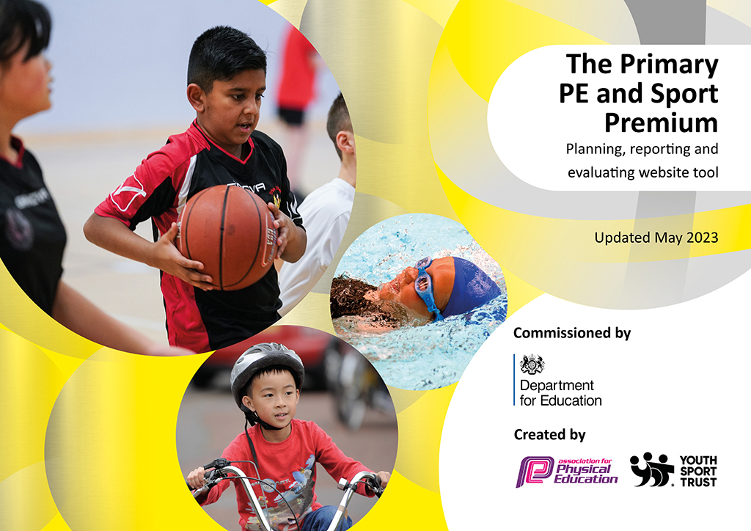
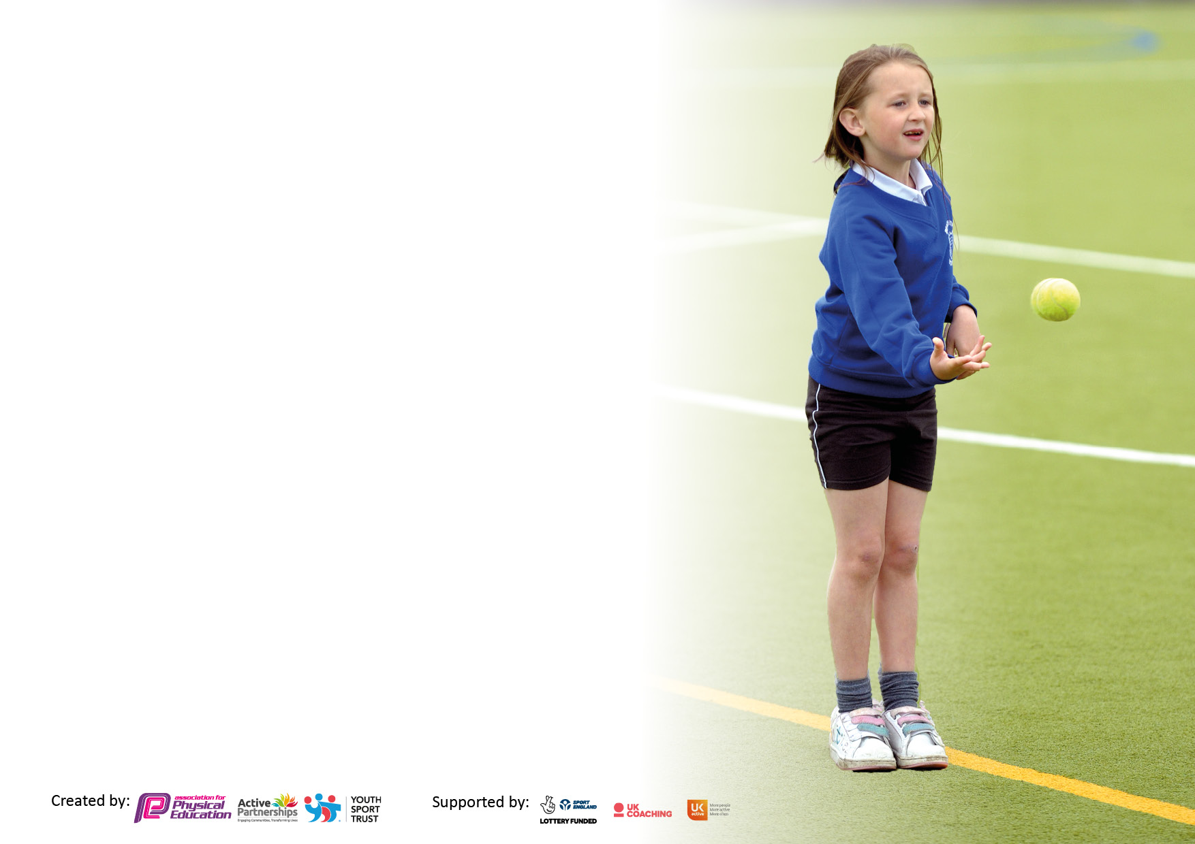

It is important that your grant is used effectively and based on school need. The Education Inspection Framework makes clear there will be a focus on ‘whether leaders and those responsible for governors all understand their respective roles and perform these in a way that enhances the effectiveness of the school’.

Under the Quality of Education Ofsted inspectors consider:
Intent - Curriculum design, coverage and appropriateness
Implementation - Curriculum delivery, Teaching (pedagogy) and Assessment
Impact - Attainment and progress

To assist schools with common transferable language this template has been developed to utilise the same three headings which should make your plans easily transferable between working documents.

Schools must use the funding to make additional and sustainable improvements to the quality of Physical Education, School Sport and Physical Activity (PESSPA) they offer. This means that you should use the Primary PE and sport premium to:

- Develop or add to the PESSPA activities that your school already offer
- Build capacity and capability within the school to ensure that improvements made now will benefit pupils joining the school in future years
- The Primary PE and sport premium should not be used to fund capital spend projects; the school’s budget should fund these.

Pleasevisitgov.ukfortherevisedDfEguidanceincludingthe5keyindicatorsacrosswhichschoolsshoulddemonstrate animprovement.Thisdocumentwillhelpyoutoreviewyourprovisionandtoreportyourspend.DfEencouragesschools to use this template as an effective way of meeting the reporting requirements of the Primary PE and Sport Premium.

We recommend you start by reflecting on the impact of current provision and reviewing the previous spend.

Schools are required to publish details of how they spend this funding, including any under-spend from 2021/2022, as well as on the impact it has on pupils’ PE and sport participation and attainment. All funding must be spent by 31st July 2023.

We recommend regularly updating the table and publishing it on your website throughout the year. This evidences your ongoing self-evaluation of how you are using the funding to secure maximum, sustainable impact. Final copy must be posted on your website by the end of the academic year and no later than the 31st July 2023. To see an example of how to complete the table please click HERE.

Details with regard to funding
Please complete the table below.

Total amount carried over from 2021/22 | £31,265.06* (£6,039.32 of funding not allocated)  £25,225.74- allocated to fund new adventure playground. Awaiting work to be completed for invoice to be paid.
Total amount allocated for 2021/22 | £18,520
How much (if any) do you intend to carry over from this total fund into 2022/23? | £6,039.32
Total amount allocated for 2022/23 | £18,490
Total amount of funding for 2023/23. To be spent and reported on by 31st July 2023. | £ 24, 529.32
Swimming Data
Please report on your Swimming Data below.

Meeting national curriculum requirements for swimming and water safety.

N.B. Complete this section to your best ability. For example you might have practised safe self-rescue techniques on dry land which you can then transfer to the pool when school swimming restarts.
Due to exceptional circumstances priority should be given to ensuring that pupils can perform safe self rescue even if they do not fully meet the first two requirements of the NC programme of study
What percentage of your current Year 6 cohort swim competently, confidently and proficiently over a distance of at least 25 metres?  N.B. Even though your pupils may swim in another year please report on their attainment on leaving primary school at the end of the summer term 2022.  Please see note above | Class 1  43.33%  Class 2  62.07%
What percentage of your current Year 6 cohort use a range of strokes effectively [for example, front crawl, backstroke and breaststroke]?  Please see note above | Class 1  70%  Class 2  58.62%
What percentage of your current Year 6 cohort perform safe self-rescue in different water-based situations? | Class 1  96.67%  Class 2  100%
Schools can choose to use the Primary PE and sport premium to provide additional provision for swimming but this must be for activity over and above the national curriculum requirements. Have you used it in this way? | Yes/No

Action Plan and Budget Tracking
Capture your intended annual spend against the 5 key indicators. Clarify the success criteria and evidence of impact that you intend to measure to evaluate for pupils today and for the future.

Academic Year: 2022/23 | Total fund allocated: | Date Updated:
Key indicator 1: The engagement of all pupils in regular physical activity – Chief Medical Officers guidelines recommend that primary school pupils undertake at least 30 minutes of physical activity a day in school |  |  |  | Percentage of total allocation:
 |  |  |  | %
Intent | Implementation |  | Impact
Your school focus should be clear what you want the pupils to know and be able to do and about  what they need to learn and to  consolidate through practice: | Make sure your actions to achieve are linked to your intentions: | Funding allocated: | Evidence of impact: what do pupils now know and what can they now do? What has changed?: | Sustainability and suggested next steps:
LINKs membership  Provides access to local/cluster tournaments and events. A specialist is provided by LINKs to support us in school.  Adventure playground project.  To increase physical activity at playtimes for all children.  To provide good quality equipment for all in PE and games | Sports leader training  Installation of adventure playground  New equipment | £1668.25  £25,225.74  £2,264.33 | Y6 sports leaders training provided by Megan Pinder at LINKs. This has ensured active lunchtimes for all children.  Lunchtime and after school clubs delivered by skilled coaches.  CPD support provided in dance to Y3 staff.  Big spend project to increase physically active play and lunchtimes for all current pupils at Nook Lane. To improve agility skills such as climbing, balancing, strength etc  Purchase of PE and sports equipment to replace broken/missing items. This enables all children to access good quality, differentiated PE lessons and extra-curricular opportunities. | Training for sports leaders to be booked for the next academic year.  This project has great longevity and will impact children at Nook Lane for years to come.
Key indicator 2: The profile of PESSPA being raised across the school as a tool for whole school improvement |  |  |  | Percentage of total allocation:
 |  |  |  | %
Intent | Implementation |  | Impact
Your school focus should be clear what you want the pupils to know and be able to do and about  what they need to learn and to  consolidate through practice: | Make sure your actions to achieve are linked to your intentions: | Funding allocated: | Evidence of impact: what do pupils now know and what can they now do? What has changed?: | Sustainability and suggested next steps:
Attendance at EIS for partnership games.  Fitness week and monitoring of children’s activity levels across school | Coach hire for Y3 for attendance at event  Purchase of fitness trackers | £390  £2,519.73 | Opportunity for all Y3 children to attend a sporting venue and take part in a variety of athletic events with other schools.  Bought in readiness for next academic year for use by the whole school to raise the profile of physical activity and monitor this across school | Attend again next year

Key indicator 3: Increased confidence, knowledge and skills of all staff in teaching PE and sport |  |  |  | Percentage of total allocation:
 |  |  |  | %
Intent | Implementation |  | Impact
Your school focus should be clear | Make sure your actions to | Funding | Evidence of impact: what do | Sustainability and suggested
what you want the pupils to know | achieve are linked to your | allocated: | pupils now know and what | next steps:
and be able to do and about | intentions: |  | can they now do? What has
what they need to learn and to |  |  | changed?:
consolidate through practice:
Increase confidence of PE leader in city wide news and key headlines for PE  Staff allocated time to develop planning of units across the curriculum when GetSet4PE isn’t used.  Time given to PE lead to plan and prepare for events etc.  Staff cover needed to take children to events/competitions | Attendance at PE conference  Staff cover  Staff cover | £104.46  £378  £1,714.01 | Knowledge of upcoming events and where to access support in the coming year.  Dance planning developed to be used in future years. Improved sequence of teaching delivered to children. | Specific CPD to be identified for individual staff going into the next academic year against new curriculum map.
Key indicator 4: Broader experience of a range of sports and activities offered to all pupils |  |  |  | Percentage of total allocation:
Intent | Implementation |  | Impact
Your school focus should be clear | Make sure your actions to | Funding | Evidence of impact: what do | Sustainability and suggested
what you want the pupils to know | achieve are linked to your | allocated: | pupils now know and what | next steps:
and be able to do and about | intentions: |  | can they now do? What has
what they need to learn and to |  |  | changed?:
consolidate through practice:
Increase participation in city wide events for children in the Integrated Resource to ensure opportunities for all.  Remapping of the curriculum across school to provide opportunities for a wider range of sports. | Mini bus hire  Handball equipment | £350  £138.96 | All children in the integrated resource took part in a city wide bowling event.  Handball now accessed by all Y6 pupils | Increased confidence in participation for these children which we would like to improve moving into next year.  Try to access some training for staff teaching new sports to increase staff confidence.

Key indicator 5: Increased participation in competitive sport |  |  |  | Percentage of total allocation:
 |  |  |  | %
Intent | Implementation |  | Impact
Your school focus should be clear | Make sure your actions to | Funding | Evidence of impact: what do | Sustainability and suggested
what you want the pupils to know | achieve are linked to your | allocated: | pupils now know and what | next steps:
and be able to do and about | intentions: |  | can they now do? What has
what they need to learn and to |  |  | changed?:
consolidate through practice:
Increase opportunities for children to take part in competitive events across the city. | Subscription to Sheffield Federation for School Sport  Attendance at the qualification round and final rounds of the climbing competition at the Climbing Works  Attendance at city wide football tournaments | £72.80  £250  £190  £180  £120  £200 | Children to attend city wide athletics event and to take part in cross country league.  Y3/4 girls came 3rd in the league  Y5/6 girls came 5th in the league  Y5/6 boys came 5th in the league  18 children participated in the qualification round and a team of finalists were taken for the second round. Nook Lane came 6th in the Primary Rounds.  Girls and boys football tournament to conclude weekly training sessions in school. | This has kick started our participation in cross country again this year and we want to continue to build our running team next year.  Attendance at this event next year to give different children the opportunity to take part.

Signed off by
Head Teacher: | Steven Arbon-Davis
Date: | 28/7/23
Governor: | Diane Shaw
Date: | 28/7/23

