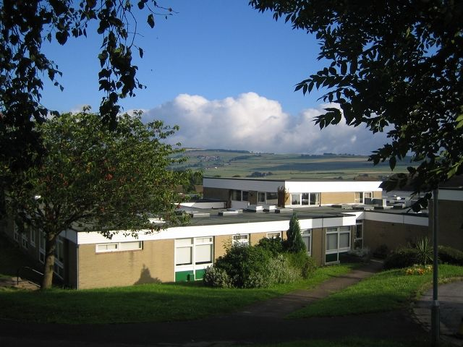
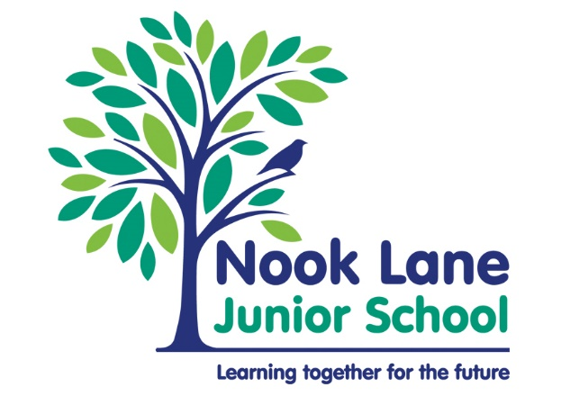

Nook Lane
Integrated Resource

Information and Vision Document

“Learning together for the future”
Written by
Alicea Shepherd
IR LEAD

What is our Vision?
In the Integrated Resource (IR) our vision, is for all children, to be able to access a tailored curriculum which gives them the very best chance to reach their potential. We believe that all pupils are entitled to a broad and rich curriculum, whilst understanding that children often need school life and curriculums adapting to meet their need. Our children need the support, professional knowledge and a flexible approach in order to access a mainstream school environment.

Who attends Nook Lane Integrated Resource?

Nook Lane IR is a 13 funded place Integrated Resource for children who have an Educational Health Care Plan (EHCP). The IR mainly caters for children, whose primary need is a level 3 and above on the Sheffield Support Grid (SSG) in Social Communication (1B); we also have some children who are a level 3 or above for Emotional and Mental Health (3A AND 3B).
The IR is for junior aged children with every child in the Integrated Resource having a place in a mainstream classroom. We often talk to the children about having two homes at Nook Lane. Their mainstream class is one home and the IR their second home.
Places for the IR are allocated by the Local Authority.
The IR has a “Memorandum of Understanding” with the Local Authority which outlines the terms between the school and the Local Authority.
The IR also has a local offer which can be found at https://www.sheffielddirectory.org.uk/kb5/sheffield/directory/service.page?id=VPxurcRfLn0

How does integration work at Nook Lane?

At Nook Lane we have a flexible and adaptable approach to integration; we do not try and make one size fit all. We understand that every child needs a personalised way to approach integration. The aim is always to increase integration over time. However, if we experience times where learning anxiety is higher, then we can reduce integration. Below is our ‘Integration Triangle’, a 3-step approach to integration. Finding ways to integrate can often start small, such as being present for the register, participating in a favorite lesson or joining an assembly, but over time, with the correct support, it can build into something much bigger such as full lessons, or, in some cases, whole days.
The Integration Triangle has an emphasis on flexibility not rigidity. To put this into context, an example may be, when a child first joins our school they may have had a difficult experience at a previous school, they will need time to settle and we will need time to identify triggers and strategies that best support the child. Within this time, they may access less time in class. When strategies and routines are implemented we may then be able to move up the integration triangle. Another example could be, if a pupil is integrating well but circumstances change at home, anxiety may increase and we may need to decrease time within the classroom to lower anxiety, as the anxiety may impact on the child’s engagement.
The Integration Triangle – the three tiers of integration and The six approaches of support

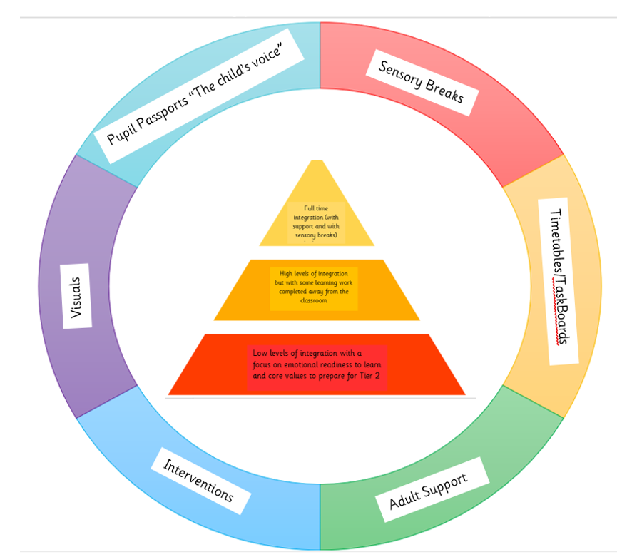
Within integration, it is important that we build in what is needed to help children to be ready to learn emotionally, the six approaches of support help us move up the tiers of integration. We can adapt where necessary and implement the school’s curriculum via the 3 tiers of integration. Tier 1 is often where our pupils start, we focus on them gaining the Nook Lane’s core values to give them that emotional readiness to learn. When core values begin to be imbedded we can start to move up the integration triangle.

Adult Support

Our children work on a 1:2 or 1:3 adult to child ratio. We try and pair children based on their year group. Occasionally we will pair pupils together based on learning ability, so that children can follow a bespoke timetable together. Support is fluid and timetabled based on need. There may be occasions when a child is unsupported (building resilience and independence) but may receive some 1:1 intense support at another point within the day. It is important to realise that timetables of support are not an easy jigsaw that always fit together neatly. Throughout the year, we often have to adapt and edit timetables.
Every child has a key worker who is responsible for annotating EHCP targets, assessing using the Birmingham toolkit and keeping their pupil passport up to date.
We think it is important that a child does not always work with the same Teaching Assistant (TA) every day. If the staff member is absent, this can heighten anxiety for a child. We try to promote the concept that the IR is a team and all of the staff are here to help each pupil. We also encourage children to consider the team around them which can include members of staff, in any roles, across school (a team around the child).
We do try and keep the timetable of support consistent, where possible.

One Page Profile/ Learner profile - “The child‘s voice”

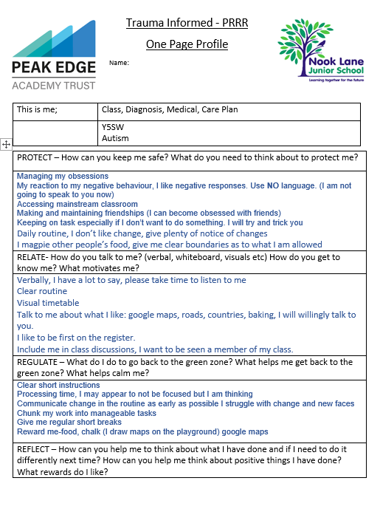The learner profile is an incredibly useful document that gives us an insight into the child’s voice and ways we can help the child. It also helps us to understand behaviour and respond appropriately. There is a shared understanding in the IR and across school that all behavior is communication.
We use a colour coded system on our learner profiles. Green represents the child’s voice, blue indicates school’s voice and red represents the parent’/carer’s voice. This ensures that all views are included.
Our format for these is trauma informed, it uses the method of PRRR. Protect, Relate, Regulate and Reflect.
Protect – how can you keep me safe?
Relate – How do you get to know me?
Regulate – How do you keep me calm?
Reflect – How can you support me to think about things that I have done?

Timetables / Taskboards

Every child within the IR has their own timetable. For each pupil the timetable provides clarity and consistency which ensures that each child is clear about what they are learning each day. Also, any adult working with a child is clear about how that pupils day is structured.
Below are some examples of timetables

The next step, after a weekly timetable, is that every individual session is broken down for the child using either, whiteboards, ‘Now and Next’ boards or Taskboards. These are all extremely useful resources to help children with Autism Spectrum Disorder (ASD) or Pathological Demand Avoidance (PDA) traits. The resource provides structure, routine and clear expectations. For demand avoidant children, it often gives the illusion that the board is providing the demand and not the adult. These instructions can be written or represented visually, depending on what the child responds to best. It is important that taskboards do not become too rigid, so flexibility is important. Staff are well trained to identify high points of anxiety which can lead to refusals. Staff present taskboards at the start of the day and working with the child, identify any sessions or tasks that can raise anxiety. These can then be adjusted if necessary.
Below are some examples
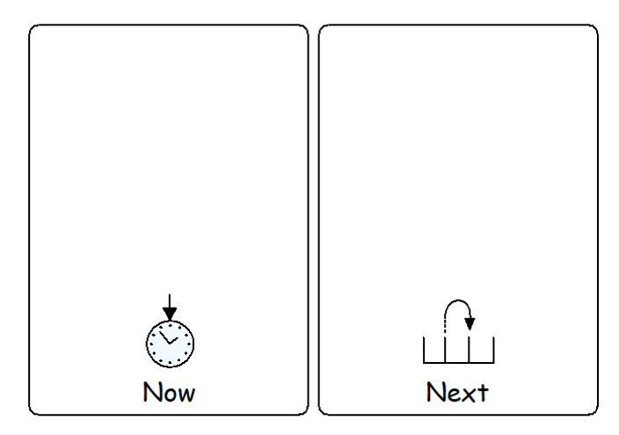

Sensory break
After all tasks, we provide breaks and “choose time.” Sometimes some children, whilst completing the task, will need to take breaks and often use break cards. It is important a child has a boundary and expectation on how often a break card can be used. However, it is important not to view a sensory break as just ‘choose time’. These are vital to meeting the child’s sensory needs. Sensory breaks can happen in the classroom, outside the classroom, in the IR or outside. Many of our children are sensory seeking so it is important we provide times to meet sensory needs. For example, some of our children may have a chew toy or use a wobble cushion; they may need a deep pressure or a light touch approach.
Some ways that we provide sensory breaks include: running outside, scooter time, playing with a ball, playing in the water tray, calm relax time, tents, sand, play doh etc.

Visuals

Visual supports, aid and enhance communication. They provide children with speech and language and communication needs with an alternative mode of communication. Visuals can help to provide structure and routine, improve understanding, avoid frustration and offer opportunities to interact with others. We try and use visuals wherever possible, if the child responds positively to them.

Our use of language is incredibly important and we try to adapt this to what the child needs at a given time. For example, if they are angry we will use less language.
We always take advice from the Speech and Language team.
We have close links with The Autism Team and they also support us on the use of visuals.

We often use social stories as a way of explaining or a way of providing information to a child who is struggling to grasp a point. For example, “when can I use the computer?”, or “what will happen when I go swimming?”
We use a program called Communication in Print to help with visuals

We also try to help children visualise behaviour by referring to “red and green behaviour”. This helps us to use positive language when talking about behaviour. For example, if a child is shouting out, we encourage the child to use a green behavior i.e. putting a hand up.

Examples of visuals and a social story

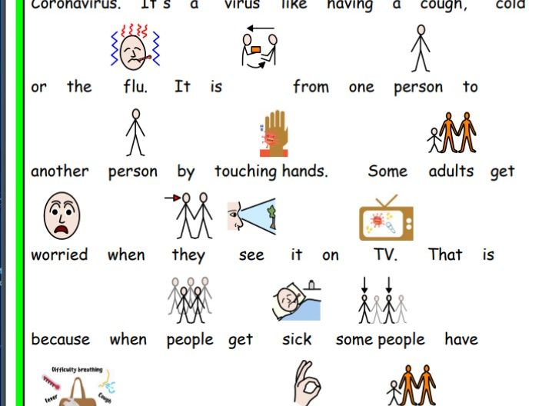
.

.

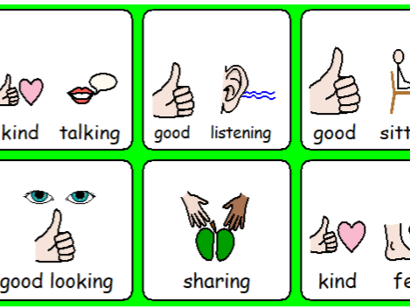
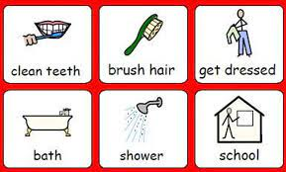

Interventions

To help target EHCP outcomes more effectively, we use a variety of interventions. These can be group interventions or 1:1 intervention. These do depend on staffing and time limitations.

Some examples are

- Speech and Language interventions
- NIP VIP and Leap
- Attention Autism
- Building block therapy
- Zones of regulation
- Baking
- Nessy fingers

What curriculum do we follow within the IR and how do we deliver it?
Within the IR, we have a wide range of timetable packages, depending on need. This refers back to our 3 tiered approach to integration (please refer back to the diagram on page 3). We are aspirational and want to aim high for our learners. We want our learners to have a curriculum offer that considers the core and wider curriculum, alongside other areas needed such as life skills. We make an ongoing informed decision about timetables and consider what is appropriate for our learners and what they can and cannot access. We think about their emotional and social interaction needs and how we can help them make progress. During the morning, every child participates in a Maths, Reading/Spelling and English activity. The level, time spent and where this is accessed will be different for every child. The IR lead, class teachers and the IR Higher Level Teaching Assistant (HLTA) are responsible for planning of these sessions. For most children, this will be mainly accessed in the mainstream classroom with support.
As part of the curriculum, we also believe in two-way integration. For example, we have a three times a week phonics group that includes pupils from the IR and from mainstream. Another example of two-way integration is when some of our IR children access a Rainbow Readers group in the Year 5 classroom.

Wider curriculum
At Nook Lane we have ambitious aims for all with regards to the wider curriculum. The majority of children will integrate, with support, into afternoon mainstream lessons. They will follow the task then choose routine. At Nook Lane, our vision has six-strands which is underpinned by our core values. As it states on our website; “Our core values are designed to support our six key aims in a child-friendly way encouraging our children to develop positive attitudes, behaviours and mind-sets so children can be successful learners and citizens; they will be a focus for our children within lessons and across school so they are 'lived and not laminated'.” Every core value, is an applicable and a valuable intention, for every pupil within the IR. Further information about Nook Lane’s curriculum vision, core values and the three Is can be found on our website https://www.nooklanejunior.co.uk/curriculum.php.

To outsiders our approach, to the wider curriculum, can sometimes appear a little ‘ad hoc’ but all of our work is to help our learners be emotionally ready to learn. Every activity will have either an academic or emotionally readiness to learn intent. As Trauma Informed Practitioners, we understand that if a child is not emotionally regulated then they physically cannot learn. When a child is on our first tier of integration our wider curriculum learning objectives refer back to Nook Lanes’ Core Value and therefore we support that child to develop a positive attitude, behaviour and mindset to become a successful learner. The activities we complete will have a learning objective that underpins the concept of emotional readiness to learn. We are ambitious for all learners, with the intention being, if we secure these skills within tier 1, the pupil would then progress to tier 2. Within tier 2 they would be exposed to more learning content from the wider curriculum. We have also developed an adapted History, Geography, Science and Art curriculum based on the Key Stage 1 National Curriculum. It also uses content from the Foundation Stage Curriculum. A small group of children access this learning, if the content of the mainstream subject is not at an academic level they can yet access. Each subject within the adapted curriculum has the key concepts and progression outlined.

Life Skills

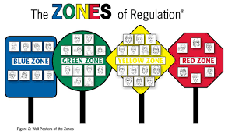
An important element of our curriculum is life skills and the development of independence. We want our children to know about the ‘real world’ and be able to function in this world. A huge part of this is anxiety management and the understanding of emotions. We teach life skills in a variety of ways such as Zones of Regulation (The Zones), small group social skill groups, bespoke emotional literacy, the involvement of self-led learning via the child’s interest, baking and trips. As explained on their website “The Zones is a systematic, cognitive-behavioral approach used to teach us how to regulate our feelings, energy and sensory needs in order to meet the demands of the situation around us and be successful socially.”
We try to bake with every child once a week. The children really enjoy these sessions and benefit from developing valuable learning such as, turn taking, sensory input, weighing and measuring and patience.
We also try to deliver a Zones of Regulation session weekly with each child; this could be part of a mainstream lesson (we use Zones as a whole school approach), a Zone of Regulation social group or a small session as part of their morning timetable. Children reflect on emotions and explore different emotions. They learn what each colour looks and feels like and they develop plans over time about how they can return to the green zone if we leave this zone.

What assessment do we use within the IR?

Assessment within the IR is crucial to identifying what we need to do next. It leads to next steps of learning which, for many of our children, are often much smaller steps. Small steps can still be aspirational. If a child is accessing their class’s curriculum and is no lower than a year behind chronological age, then assessments often happen within the classroom using whole school approaches. If a child is working at two or more years lower than chronological age we use Birmingham Toolkit to assess.

Birmingham Toolkit
The Birmingham SEN Toolkits are a set of resources to support the identification, provision and tracking progress for pupils with cognition and learning difficulties who are working significantly below the level of their peers
Birmingham Toolkit uses bands that match to each year group. It breaks the National Curriculum down into smaller steps of learning and provides a sequenced approach to assessment, helping to identify gaps easily. There is detailed information linked to every objective that can be taught, either through Quality First Teaching, smaller group and intervention work or via 1:1 learning. This makes it a practical tool for assessment. Birmingham Toolkit assesses all of the areas of the core curriculum.
Every half term, we reassess the children on the Birmingham Toolkit so we can identify our next areas of development. The toolkit influences what teaching objectives to deliver next.

Strengths and Difficulties Questionnaire (SDQ)

It is important that within the IR we value emotional progress as much as academic progress. As previously mentioned if children are emotionally not ready to learn, we physically cannot learn. Therefore every term we use the Strengths and Difficulties Questionnaire to assess and give a value to social, emotional and mental health (SEMH) progress and to identify areas of concern. We conduct these assessment as an IR team approach. This gives us the opportunity to discuss and review progress and recognise our next areas of work with the child. These are valuable and crucial discussions. Completing these assessments often influences daily practice and other work such as Zones of Regulation.
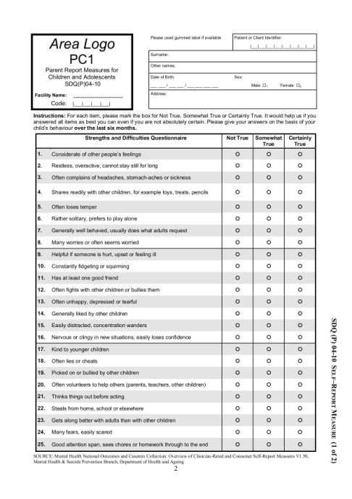

EHCP Outcomes

A child’s EHCP outcomes are a fundamental part of assessment. We make sure children’s timetables create opportunities for them to work on their outcomes. We take all professional advice and also use this to influence timetables and curriculum content. Every year the child has an Annual Review and two interim SEND reviews to discuss progress against these outcomes. When a child has met these outcomes, we will work with professionals to create new ones. If we feel any outcome is not suitable or appropriate, we will do the same. Every half term, the IR team and classroom teachers review these outcomes in the EHCP annotated sheets; this is then used to document progress by the IR lead at the reviews. Having the half termly meeting about EHCP outcomes, keeps staff informed, refreshed and vigilant in monitoring the progress of these outcomes. It is a whole team approach. At the end of each term the class teacher or IR lead will create a next step for each EHCP outcome. This is a SMART target and clearly highlights what is the next step the child needs to achieve to work towards their overall bigger outcome.

Nook Lane IR

Within the IR, practice, curriculum, approaches and assessment have to be flexible, adaptable, bespoke and practical in order to meet the needs of our children. We believe in two-way integration with mainstream and believe in always promoting integration using our three-tiered approach. We are one school and it is important that we always recognise we are part of a mainstream school, that we cannot offer the same environment as a special school but that we can be that step between. We are always aiming high by trying to increase pupils’ access to integration and the mainstream curriculum.

Who can I speak to if I have any further questions?

Steve Arbon Davis - Headteacher
Alicea Shepherd - IR Lead
Louise Bullen– Assistant Headteacher and Curriculum Lead

Nook Lane Junior School
Nook Lane
Sheffield
S6 6BN

0114 2341097

enquiries@nooklane.sheffield.sch.uk
iruclass@nooklane.sheffield.sch.uk

