Curriculum: Languages (Spanish)

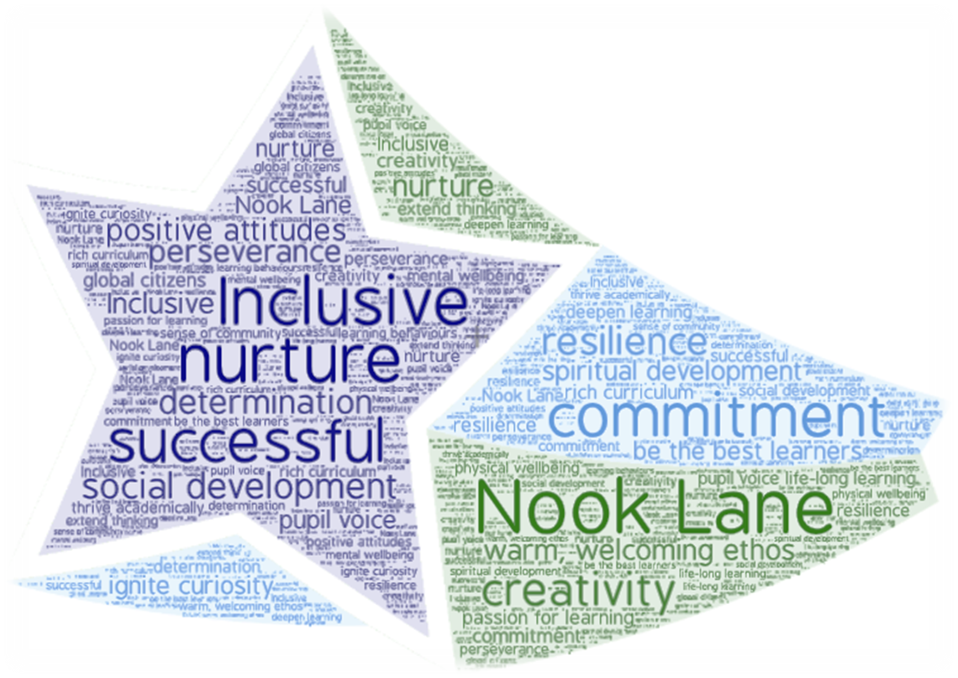

- Vision
- Intent, Implementation & Impact
- National Curriculum
- Overview of learning
- Progression

2022-2023

Vision
“Learning another language is not only thinking about words for the same things, but learning another way to think about things” (Flora Lewis)
At Nook Lane Junior School, it is our intention that children receive high-quality language lessons taught by Modern Foreign Language specialists that enable all children to experience learning and using a foreign language in a way that is engaging, inclusive and exciting. We aim to stimulate and encourage children’s curiosity about language, develop an interest in learning other languages and broaden their understanding of cultural differences and similarities. By promoting an awareness of and respect for our diverse and changing world, we aim for our children to make valuable contributions to the community locally, nationally and globally.
We strive to encourage children’s motivation, resilience and self-esteem by enabling them to experience success in learning a foreign language in an inclusive way. By progressively enhancing children’s skills in listening, speaking, reading and writing, we aim to develop their ability to communicate in a variety of ways for practical purposes. We aim to cultivate a positive attitude towards, and lay the foundations for future language learning.
Intent
At Nook Lane Junior School, we aspire to help children develop as linguists, building progressively each year on the following Spanish key intentions:
MFL1 |  | Children will understand spoken Spanish and show understanding by responding and joining in. They will link the sound and spelling amd meaning of words.
MFL2 |  | Children will speak Spanish with accurate pronunciation and intonation. They will engage in conversations, ask and answer questions, present information and express opinions in Spanish.
MFL3 |  | Children will read and show understanding of words, phrases and simple written Spanish. They will use different strategies to understand unfamiliar words, the main points and some details in short written texts in Spanish.
MFL4 |  | Children will describe people, places, things and actions in writing, sometimes from memory. They will be able to manipulate famililiar language to create new sentences using prior knowledge of grammar and key features.
MFL5 |  | Children will understand basic Spanish grammatical concepts and know how to apply them both orally and in writing.
Key Concepts |  | Our Modern Foreign Languages key intentions and concepts are captured within our MFL Logo.  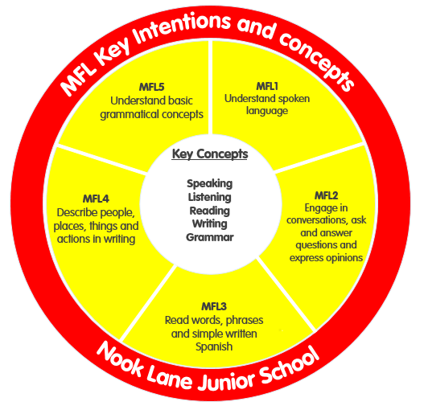
Implementation
- All children have one 50 minute Spanish lesson per week taught by specialist Modern Foreign Language teachers.
- The curriculum is ambitious and follows the national curriculum programme of study.
- Lesson activities are challenging, varied and interactive and develop listening, reading, speaking and writing skills.
- Lessons are designed to be progressive and build on prior learning, moving from word to sentence level over the four years. The choice of vocabulary ensures exposure to all the key phonic sounds and ability to build sentences using grammatical knowledge.
- The curriculum uses a variety of strategies to engage the children and develop their confidence and enjoyment of language learning. These include songs, games, role-plays, familiar books and stories, video clips and art activities. Bilingual dictionaries and word mats provide support and opportunities for challenge.
- To enhance the impact on enjoyment and intercultural understanding, we organise a whole school Spanish day and have a link with a school near Alicante.
Impact
- By the end of Year 6, children will have developed key language learning skills, as set out by the national curriculum. They are able to understand longer and more challenging texts on a range of topic areas, compose their own sentences in conversations using knowledge of basic sentence structure and write a range of phrases and sentences from memory and adapt them to write their own sentences.
- On leaving Nook lane children are enthusiastic and positive about learning a foreign language and inspired to learn more.
- Children understand that language has a structure and that that structure may differ from one language to another.
- Children can talk about Spain and other Spanish speaking countries and can identify similarities and differences in everyday life, social conventions and celebrations with their own, whilst understanding and respecting cultural diversity.
- Children will develop an in-depth understanding of the following concepts that are continually returned to and discussed within each unit of learning so they can answer the ‘bigger questions’ listed below:

- Listening – Why is is important to develop my listening skills and how does this skill link to the other skills of speaking, reading and writing?
- Speaking – How can I develop correct pronunciation and intonation?
- Reading – What language learning strategies can I use to help me read familiar and unfamiliar words and phrases?
- Writing – What previously learnt words and phrases can I use to improve my writing?
- Grammar - How is Spanish grammar similar to and different from English grammar? Can I use this knowledge to improve the accuracy of my Spanish?

National Curriculum
Purpose of study
Learning a foreign language is a liberation from insularity and provides an opening to other cultures. A high-quality languages education should foster pupils’ curiosity and deepen their understanding of the world. The teaching should enable pupils to express their ideas and thoughts in another language and to understand and respond to its speakers, both in speech and in writing. It should also provide opportunities for them to communicate for practical purposes, learn new ways of thinking and read great literature in the original language. Language teaching should provide the foundation for learning further languages, equipping pupils to study and work in other countries.
Aims
The national curriculum for languages aims to ensure that all pupils:
- understand and respond to spoken and written language from a variety of authentic sources
- speak with increasing confidence, fluency and spontaneity, finding ways of communicating what they want to say, including through discussion and asking questions, and continually improving the accuracy of their pronunciation and intonation
- can write at varying length, for different purposes and audiences, using the variety of grammatical structures that they have learnt
- discover and develop an appreciation of a range of writing in the language studied.
Attainment targets
- By the end of each key stage, pupils are expected to know, apply and understand the matters, skills and processes specified in the relevant programme of study.
- Schools are not required by law to teach the example content in [square brackets].
- Languages – key stage 2
Subject content Key stage 2: Foreign language
- Teaching may be of any modern or ancient foreign language and should focus on enabling pupils to make substantial progress in one language. The teaching should provide an appropriate balance of spoken and written language and should lay the foundations for further foreign language teaching at key stage 3.
- It should enable pupils to understand and communicate ideas, facts and feelings in speech and writing, focused on familiar and routine matters, using their knowledge of phonology, grammatical structures and vocabulary.
- The focus of study in modern languages will be on practical communication. If an ancient language is chosen the focus will be to provide a linguistic foundation for reading comprehension and an appreciation of classical civilisation.
- Pupils studying ancient languages may take part in simple oral exchanges, while discussion of what they read will be conducted in English. A linguistic foundation in ancient languages may support the study of modern languages at key stage 3.
Pupils should be taught to:
- listen attentively to spoken language and show understanding by joining in and responding
- explore the patterns and sounds of language through songs and rhymes and link the spelling, sound and meaning of words
- engage in conversations; ask and answer questions; express opinions and respond to those of others; seek clarification and help*
- speak in sentences, using familiar vocabulary, phrases and basic language structures
- develop accurate pronunciation and intonation so that others understand when they are reading aloud or using familiar words and phrases*
- present ideas and information orally to a range of audiences*
- read carefully and show understanding of words, phrases and simple writing appreciate stories, songs, poems and rhymes in the language
- broaden their vocabulary and develop their ability to understand new words that are introduced into familiar written material, including through using a dictionary
- write phrases from memory, and adapt these to create new sentences, to express ideas clearly describe people, places, things and actions orally* and in writing
Languages – key stage 2
- Understand basic grammar appropriate to the language being studied, including (where relevant): feminine, masculine and neuter forms and the conjugation of high-frequency verbs; key features and patterns of the language; how to apply these, for instance, to build sentences; and how these differ from or are similar to English.
- The starred (*) content above will not be applicable to ancient languages.
Overview of learning
 | Autumn 1 |  | Autumn 2 |  |  | Spring 1 |  |  | Spring 2 | Summer 1 |  |  | Summer 2
Year 3 | Greetings and saying how you feel  Asking and giving name  Numbers 1-12  Introduction to sounds of Spanish and vowel sounds  Day of the Dead |  | Colours  Numbers up to 31  Asking and saying how old you are  Classroom instructions  Christmas in Spain |  |  | Using a bilingual dictionary  In my pencil case |  |  | Pets  Easter in Spain | Days of the week  Months of the year |  |  | Spanish speaking countries  Spanish artist.
Year 4 | Wild animals |  | My family  Christmas traditions |  |  | Food and drink  Expressing opinions about food and drink |  |  | Parts of the body and saying what hurts | Geography of Spain  Compass points  Weather |  |  | Saying where you live and what languages you speak  Latin American geography and culture
Year 5 | Hobbies and free-time activities  Expressing opinions |  | My town  Christmas activities |  |  | Parts of the body Aliens |  |  | Clothes | Planets |  |  | Telling the time  Art - Miró  Festival - San Fermin.
Year 6 | Describing people |  | Transport  Christmas activities |  |  | Times of the day  Daily routine |  |  | An interview with … | Talking about countries, nationalities and languages |  |  | Introduction to French
Subject Progression
MFL1 - Understand spoken Spanish and link the sound, spelling and meaning of words - Listening

NC
- listen attentively to spoken language and show understanding by joining in and responding
- explore the patterns and sounds of language through songs and rhymes and link the spelling, sound and meaning of words

Year 3 |  |  |  | Year 4 |  |  | Year 5 |  |  |  | Year 6
- Listen and show understanding of single words through physical response  - Listen and identify rhyming words and particular sounds in songs and rhymes  - Link the sound, spelling and meaning of words. |  |  |  | - Listen and show understanding of short phrases through physical response  - Listen and demonstrate understanding of words in songs and rhymes |  |  | - Listen and show understanding of more complex familiar phrases and sentences  - Follow the text of familiar rhymes and songs identifying the meaning of the words |  |  |  | - Listen and show understanding of more complex sentences containing familiar and unfamiliar words
MFL2 - Speaking

NC
- engage in conversations; ask and answer questions; express opinions and respond to those of others; seek clarification and help*
- speak in sentences, using familiar vocabulary, phrases and basic language structures
- develop accurate pronunciation and intonation so that others understand when they are reading aloud or using familiar words and phrases*
- present ideas and information orally to a range of audiences

Year 3 |  |  |  | Year 4 |  |  | Year 5 |  |  |  | Year 6
- Repeat modelled words correctly.  - Recognise a familiar question and respond with a simple rehearsed response  - Name objects and actions and link words with a connective in a simple rehearsed statement  - Join in with actions to accompany familiar songs, stories and rhymes and say some of the words  - Develop accurate pronunciation  - Recognise Spanish sounds that are different to English |  |  |  | - Ask and answer several simple and familiar questions with a rehearsed response  - Use familiar vocabulary to say simple sentences to give information using a language scaffold  - Join in with the words of a rhymes, song or story sometimes from memory |  |  | - Ask and answer more complex familiar questions with a scaffold of responses, maybe asking for clarification and help  - Use familiar vocabulary to say more complex sentences such as presenting ideas using a language scaffold |  |  |  | - Read aloud the text of familiar rhymes and songs  - Engage in a short conversation using familiar questions and express opinions  - Pronounce unfamiliar words in a sentence using knowledge of phonics and letter strings  - Manipulate familiar language to present own ideas and information in more complex sentences
MFL3 – Read and show understanding of words, phrases and simple written Spanish
NC
- read carefully and show understanding of words, phrases and simple writing appreciate stories, songs, poems and rhymes in the language
- broaden their vocabulary and develop their ability to understand new words that are introduced into familiar written material, including through using a dictionary
Year 3 |  |  |  | Year 4 |  |  | Year 5 |  |  |  | Year 6
- Using the knowledge of the sound of some letter strings, read aloud or say individual familiar words  - Read and show understanding of familiar single words  - Identify and use strategies for memorising new vocabulary |  |  |  | - Read aloud familiar short sentences using knowledge of letter string sounds  - Read and show understanding of simple familiar phrases and short sentences  - Use a bi-lingual dictionary to find the meaning of a word or its translation |  |  | - Follow the simple text of a familiar song or story and sing or read aloud  - Read aloud more complex sentences using knowledge of phonics  - Read and show understanding of a complex sentence using familiar language  - Use a bi-lingual dictionary to find the meaning of nouns in the plural, adjectives in agreement and conjugated verbs |  |  |  | - Understand the gist of an unfamiliar text using some familiar language  - Read and show understanding of a series of complex sentences using familiar language  - Decode a simple unfamiliar text using grammatical knowledge, context or a bi-lingual dictionary
MFL4 - Writing
NC
- write phrases from memory, and adapt these to create new sentences, to express ideas clearly describe people, places, things and actions orally* and in writing
Year 3 |  |  |  | Year 4 |  |  | Year 5 |  |  |  | Year 6
- Write and say simple familiar words to describe people, places, things and actions using a model  - Write single familiar words with understandable accuracy |  |  |  |  | - Write and say a simple phrase to describe people, places, things and actions using a language scaffold  - Write simple familiar short phrases with understandable accuracy |  |  | - Write and say a more complex sentence to describe people, places, things and actions using a language scaffold  - Write familiar complex sentences with understandable accuracy |  |  |  | - Write and say a complex sentence manipulating familiar language, using a dictionary for new language  - Write complex sentences manipulating familiar vocabulary with understandable accuracy
MFL5 – Understand basic grammatical concepts
NC
- Understand basic grammar appropriate to the language being studied, including (where relevant): feminine, masculine and neuter forms and the conjugation of high-frequency verbs; key features and patterns of the language; how to apply these, for instance, to build sentences; and how these differ from or are similar to English.
Year 3 |  |  |  | Year 4 |  |  | Year 5 |  |  |  | Year 6
- Name a noun, adjective, conjunction in Spanish  - Use a regular verb in the 1st and 2nd person |  |  |  |  | - Use the correct form of the indefinite article in the singular, according to the gender of the noun, and in the plural  - Demonstrate understanding of the position of the majority of adjectives |  |  | - Apply the rules of the agreement of adjectives in the singular and plural with some accuracy  - Produce positive and negative sentences with high frequency verbs |  |  |  | - Use the correct form of the definite article in singular and plural sentences  - Conjugate a few high frequency regular and irregular verbs  - Use adverbs of time  - Apply all grammatical knowledge learnt to build complex sentences

