Curriculum: Design Technology

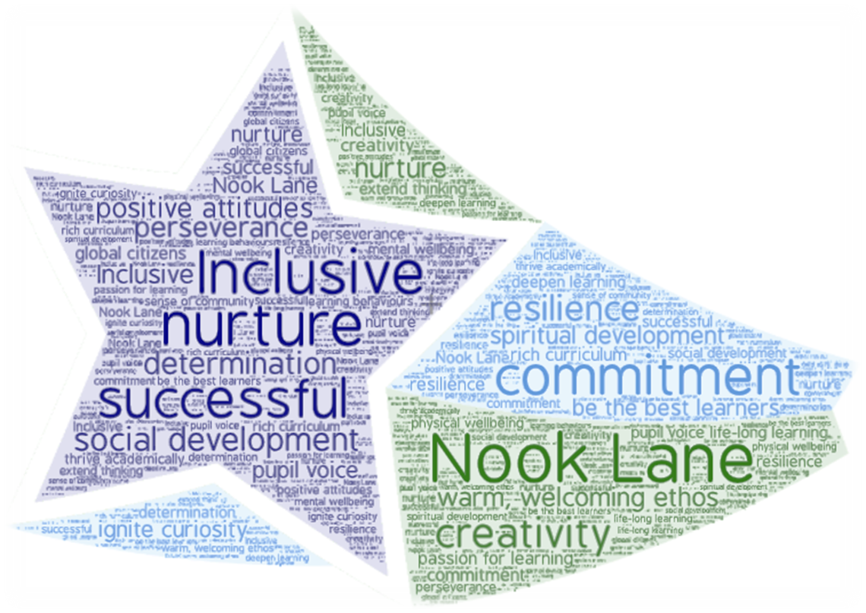

- Vision
- Intent, Implementation & Impact
- National Curriculum
- Overview of learning
- Progression

Vision
At Nook Lane Junior School we endeavour for our children to receive high-quality design technology lessons that enable them to gain experiences in designing, making and evaluating products. Design technology calls for pupils to become creative problem solvers both as individuals and as members of a team. Through a variety of projects design, technology ignites children’s curiosity and creativity, encouraging a passion for life-long learning. In their designing and making, pupils combine practical skills with an understanding of aesthetics and function. Throughout the curriculum we aim to teach children a wealth of life-long practical skills such as sewing, cooking, woodwork and electronics. The DT curriculum will cultivate positive attitudes and allow children to be determined, persevere and be resilient, challenging and supporting all children to be the best learners that they can be. Where possible, the curriculum will allow students to work closely together with parents, families and the local and wider community. By working alongside people from industry, the design technology curriculum will allow children to foster attitudes which enable then to become responsible and caring global citizens prepared for the opportunities and challenges of tomorrow.
Intent
At Nook Lane Junior School, we aspire to help children develop as designers, building progressively each year on the following Design Technology key intentions:
 | Children will evaluate and take inspiration from existing products considering innovations. They can/ will use their research of existing products to develop design criteria for innovative, functional, appealing products that are fit for purpose and aimed at particular individuals or groups.
 | Children will produce a variety of designs to communicate their ideas through discussion, annotated sketches, cross-sectional and exploded diagrams, prototypes, pattern pieces and Computer Aided Design.
 | Children will prepare and store food using different practical skills. They will understand and apply the principles of a healthy and varied diet and prepare and cook a variety of predominantly savoury dishes using a range of cooking techniques.
 | Children will work with a range of materials using different practical skills and have opportunities to select from and use a wider range of tools and equipment to perform practical tasks. Children will select from, according to their functional properties and aesthetic qualities, a wide range of materials and components,including construction materials, textiles and ingredients,
 | Children will evaluate their ideas and products against their own design criteria and consider the views of others to improve their work.
Key Concepts | Throughout their learning, children will develop an in-depth understanding of the following concepts that are continually returned to and discussed within each unit of learning so they can answer the ‘bigger questions’ listed below:  - Take inspriration – How is design used to bring about change so things are done in a new way in order to make improvements?  - Design – How do plans and drawings show the look and function of producs before they are made?  - Nutritian - How can I design products that are healthy and varied in diet?  - Make – How is science or knowledge put into practical use to solve problems or invent useful tools and techniques?  - Evaluation – Why is evaluation important in design and how is it used to consider the value, nature, character or quality of something?  Our Design Technology key intentions and concepts are captured within our DT Logo.
 | 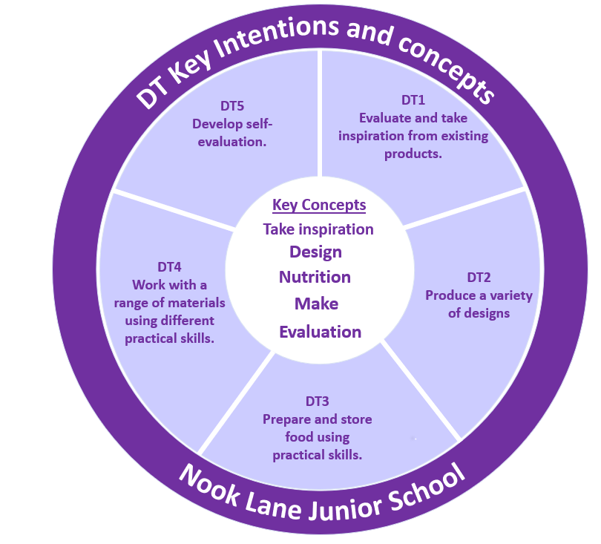
Implementation
- The National Curriculum is followed and children are given opportunities to design, make and evaluate a range of products using a variety of materials throughout key stage 2.
- DT units of work taught in each year group are linked to the theme learning that takes place in each year group and aim to inspire the children to work creatively, develop resilience and produce a finished product they are proud of.
- The skills taught in DT are progressive and allow children to create more complex products and work with a variety of materials as they move through school. The knowledge, understanding and skills progression is outlined on the DT curriculum progression map
- Where possible, DT units are linked to enterprise and developing community links.
- DT units of work enable children to develop practical skills of sewing, food technology, woodwork and electronics
- The tasks children undertake in DT allow a variety of grouping to take place to teach the children the value of working individually, in pairs and in larger groups to achieve their goals
Impact
- Children will become proficient in a range of practical skills such as sawing, sewing, cutting, joining materials which can be transferred to a variety life skills needed for the future.
- Children will become more resilient and able to work creatively and logically when faced with challenges. They will enjoy problem solving and be motivated to work through challenges methodically.
- Children will see the benefits of teamwork and understand the need to seek expertise and experience of people in the community who have skills in various areas DT.
- Children will develop an in-depth understanding of the following concepts that are continually returned to and discussed within each unit of learning so they can answer the ‘bigger questions’ listed below:

- Taking inspriration – How is design used to bring about change so things are done in a new way in order to make improvements?
- Nutritian – How can I design products that are healthy and varied in diet?
- Design – How do plans and drawings show the look and function of producs before they are made?
- Make – How is science or knowledge put into practical use to solve problems or invent useful tools and techniques?
- Evaluation – Why is evaluation important in design and how is it used to consider the value, nature, character or quality of something?

Building Knowledge Sequentially

At Nook Lane Junior School, we aim to develop children’s knowledge and skills in design and technology by building on key concepts that are central to this subject:

• Take inspiration from existing products

• Design

• Make

• Evaluate

• Food and nutrition

Children will develop their disciplinary knowledge through understanding how designers work, developing a deep understanding of the design process from project brief through to evaluation of the final product. Children will consolidate their understanding of this design process year-on-year as they tackle a range of different design briefs and projects.

Alongside their disciplinary knowledge, children will develop substantive knowledge learning a range of key skills, knowledge of a variety of construction, production and methods, knowledge of tools and approaches and knowledge of food and nutrition.
National Curriculum
National Curriculum
Purpose of study Design and technology is an inspiring, rigorous and practical subject. Using creativity and imagination, pupils design and make products that solve real and relevant problems within a variety of contexts, considering their own and others’ needs, wants and values. They acquire a broad range of subject knowledge and draw on disciplines such as mathematics, science, engineering, computing and art. Pupils learn how to take risks, becoming resourceful, innovative, enterprising and capable citizens. Through the evaluation of past and present design and technology, they develop a critical understanding of its impact on daily life and the wider world. High-quality design and technology education makes an essential contribution to the creativity, culture, wealth and well-being of the nation.
Aims
The national curriculum for design and technology aims to ensure that all pupils:
- Develop the creative, technical and practical expertise needed to perform everyday tasks confidently and to participate successfully in an increasingly technological world
- Build and apply a repertoire of knowledge, understanding and skills in order to design and make high-quality prototypes and products for a wide range of users
- Critique, evaluate and test their ideas and products and the work of others
- Understand and apply the principles of nutrition and learn how to cook
Key stage 2
Through a variety of creative and practical activities, pupils should be taught the knowledge, understanding and skills needed to engage in an iterative process of designing and making. They should work in a range of relevant contexts [for example, the home, school, leisure, culture, enterprise, industry and the wider environment]. When designing and making, pupils should be taught the following:
Design
- Use research and develop design criteria to inform the design of innovative, functional, appealing products that are fit for purpose, aimed at particular individuals or groups
- Generate, develop, model and communicate their ideas through discussion, annotated sketches, cross-sectional and exploded diagrams, prototypes, pattern pieces and computer-aided design
Make
- Select from and use a wider range of tools and equipment to perform practical tasks [for example, cutting, shaping, joining and finishing], accurately
- Select from and use a wider range of materials and components, including construction materials, textiles and ingredients, according to their functional properties and aesthetic qualities
Evaluate
- Investigate and analyse a range of existing products
- Evaluate their ideas and products against their own design criteria and consider the views of others to improve their work
- Understand how key events and individuals in design and technology have helped shape the world
Technical knowledge
- Apply their understanding of how to strengthen, stiffen and reinforce more complex structures
- Understand and use mechanical systems in their products [for example, gears, pulleys, cams, levers and linkages]
- Understand and use electrical systems in their products [for example, series circuits incorporating switches, bulbs, buzzers and motors]
- Apply their understanding of computing to program, monitor and control their products.
Cooking and nutrition
As part of their work with food, pupils should be taught how to cook and apply the principles of nutrition and healthy eating. Instilling a love of cooking in pupils will also open a door to one of the great expressions of human creativity. Learning how to cook is a crucial life skill that enables pupils to feed themselves and others affordably and well, now and in later life. Pupils will:
- Understand and apply the principles of a healthy and varied diet
- Prepare and cook a variety of predominantly savoury dishes using a range of cooking techniques
- Understand seasonality, and know where and how a variety of ingredients are grown, reared, caught and processed.
Overview of learning
 |  | Autumn 1 | Autumn 2 |  | Spring 1 |  | Spring 2 | Summer 1 |  | Summer 2
Year 3 |  | Designing and making replica Canopic Jars.  Clay skills. |  |  |  |  | Picnic preparation  (Preparing sandwiches and vegetables) |  |  | Pull-along mini beast  Wooden square based chassis with axils / wheels.
Year 4 |  |  | Sewing – applique, joining basic embroidery. Christmas decorations. |  | CAM toys linked to history |  |  | CAD and 3D printing  AMRC link.
Year 5 |  |  | Designing using pulleys.  Making wooden a longboat |  |  |  | Design and make dens  Small and large scale. |  |  | To be decided  New unit
Year 6 |  |  | Making  Scones and tiffin for Christmas fair (enterprise) |  | Modroc creatures  Wire creations |  |  | Designing a company to create a successful company uniform, 3D key badge and model and electric car
Subject Progression
Evaluate and taking inspiration from existing products considering innovation.

NC
- Use research and develop design criteria to inform the design of innovative, functional, appealing products that are fit for purpose, aimed at particular individuals or groups
- Generate, develop, model and communicate their ideas through discussion, annotated sketches, cross-sectional and exploded diagrams, prototypes, pattern pieces and computer-aided design
Year 3 |  |  |  | Year 4 |  | Year 5 |  |  | Year 6
- Suggest improvements to existing designs.  - Explore how products have been created. |  |  |  | - Improve upon existing designs, giving reasons for choices.  - Talk about how some designs have changed over time.  - Disassemble products to understand how they work. |  | - Combine elements of design from some inspirational designers.  - Investigate and analyse a range of existing products to inspire our own designs.  - Evaluate the design of products so as to suggest improvements to the user experience. |  |  | - To gather the views and opinions of users to gauge a product's strengths and weaknesses.  - Disassemble a range of products to understand how they work.  - Combine elements of design from a range of inspirational designers throughout history, giving reasons for choices.
Produce a variety of designs.

NC: Design
- use research and develop design criteria to inform the design of innovative, functional, appealing products that are fit for purpose, aimed at particular individuals or groups
- generate, develop, model and communicate their ideas through discussion, annotated sketches, cross-sectional and exploded diagrams, prototypes, pattern pieces and computer-aided design
Year 3 |  |  |  | Year 4 |  | Year 5 |  |  | Year 6
- Create a series of different sketches with annotations of your wooden moving mini-beast  - Select my most successful design.  - Create a design criteria for a product for you food at the teddy bears picnic  - Add some detail to my drawings including measurements. |  |  |  | - Create a series of different sketches with annotations to demonstrate how a cam toy moves.  - Add detail to my drawings including measurements to ensure the paper pattern for your felt bauble will be successful.  - Create a design criteria for a product. |  | - Generate, develop and communicate their ideas through, cross-sectional and exploded diagrams.  - Create innovative designs that improve upon existing products. |  |  | - Create innovative designs that improve upon existing products.  - Generate, develop, model and communicate their ideas through, cross-sectional and exploded diagrams, and prototypes.
Prepare and store food using practical skills
NC: Cooking and nutrition
As part of their work with food, pupils should be taught how to cook and apply the principles of nutrition and healthy eating. Instilling a love of cooking in pupils will also open a door to one of the great expressions of human creativity. Learning how to cook is a crucial life skill that enables pupils to feed themselves and others affordably and well, now and in later life.
- understand and apply the principles of a healthy and varied diet
- prepare and cook a variety of predominantly savoury dishes using a range of cooking techniques
- understand seasonality, and know where and how a variety of ingredients are grown, reared, caught and processed.
Year 3 |  |  |  | Year 4 |  | Year 5 |  |  | Year 6
- Cut, peel or grate ingredients safely and hygienically to make a selection of sandwiches and salads for the teddy bears picnic  - Assemble and present ingredients.  - Measure and weigh using measuring cups or scales. |  |  |  |  |  | - In preparation for the Mountain Rescue Fund Raising Event pupils make a range of edible goods.  - Prepare ingredients hygienically using appropriate utensils.  - Measure ingredients to the nearest gram accurately.  - Follow a recipe accurately. |  |  | - Understand the importance of correct storage and handling of ingredients (micro-organisms).  - Measure accurately and calculate ratios of ingredients to scale up or down from a recipe (scones and tiffin)  - Demonstrate a range of baking and cooking techniques.  - Create and refine recipes, including ingredients, methods, cooking times and temperatures.
Work with a range of materials using different practical skills
NC: Make
- select from and use a wider range of tools and equipment to perform practical tasks [for example, cutting, shaping, joining and finishing], accurately
- select from and use a wider range of materials and components, including construction materials, textiles and ingredients, according to their functional properties and aesthetic qualities
NC: Technical knowledge
- apply their understanding of how to strengthen, stiffen and reinforce more complex structures
- understand and use mechanical systems in their products [for example, gears, pulleys, cams, levers and linkages]
- understand and use electrical systems in their products [for example, series circuits incorporating switches, bulbs, buzzers and motors]
- apply their understanding of computing to program, monitor and control their products.
Year 3 |  |  |  | Year 4 |  | Year 5 |  |  | Year 6
- Cut materials safely using tools provided.  - Measure and mark out to the nearest centimetre to cut the dowel and cm² wood accurately.  - Demonstrate a range of cutting and shaping techniques.  - Demonstrate a range of joining techniques to create a wooden frame and fix axils to the chassis.  - Use materials to practise screwing, gluing and nailing materials to strengthen products. |  |  |  | - Cut materials accurately and safely by selecting appropriate tools.  - Shape textiles using templates /paper patterns  - Join textiles using running stitch.  - Decorate textiles adding sequins, buttons, applique, embroidery.  - Measure and mark out wood / card and fabric to the nearest millimetre.  - Convert rotary motion to linear using cams.  - Use scientific knowledge of the transference of forces to choose appropriate mechanisms for a product (such as levers, winding mechanisms, pulleys and gears). |  | - This unit is under review:  - Measure, mark out and cut to the nearest millimetre.  - Use drilling, screwing, gluing and nailing materials to join and strengthen products.  - Show an understanding of the qualities of materials and choose appropriate tools to cut and shape.  - Convert rotary motion to linear using pulleys.  - Use scientific knowledge of the transference of forces to choose appropriate mechanisms for a product.  - Use different joining techniques to create a waterproof den suitable for 4 /6 people to take shelter in |  |  | - Measure, mark out and cut a range of materials to the nearest millimetre to create a moving vehicle incorporating electrical components.  - Diagnose faults in battery operated devices (such as low battery, water damage or battery terminal damage).  - Create series and parallel circuits.  - Create circuits using electronics kits that employ a number of components (such as LEDs, resistors, transistors and chips).  - Measure, mark out, cut and join a range of materials to the nearest millimetre to create a uniform
Develop self-evaluation
NC: Evaluate
- investigate and analyse a range of existing products
- evaluate their ideas and products against their own design criteria and consider the views of others to improve their work
- understand how key events and individuals in design and technology have helped shape the world
Year 3 |  |  |  | Year 4 |  | Year 5 |  |  | Year 6
- Evaluate as I am working.  - Make alterations to improve my work. |  |  |  | - Refine work and techniques as work progresses, continually evaluating the product design. |  | - Make products through stages of prototypes, making continual refinements.  - Refine work and techniques as work progresses, continually evaluating the product design. |  |  | - Make products through stages of prototypes, making continual refinements.  - Evaluate the design of products so as to suggest improvements to the user experience.

